LAB EXPERIMENT 6

AIM

To design and develop an Online Cake Ordering System using HTML, CSS, and JavaScript that allows users to browse cakes, search by category, add cakes to the cart, place orders, manage delivery details, and track order status, while enabling administrators to manage cake products and customer orders.

PROCEDURE
- Create a project folder and create an HTML file named index.html.
- Use HTML to design the structure of the Online Cake Ordering System website.
- Use CSS to style the website and create a user-friendly, responsive interface.
- Use JavaScript to implement cake searching, category filtering, price filtering, and cake details.
- Create a shopping cart feature that allows users to add cakes and view the total price.
- Develop an order placement form to collect customer details and delivery addresses.
- Implement order tracking to display the current status of customer orders.
- Create an admin section to manage cake products, upload images, update prices, and manage orders.
- Open the index.html file in a web browser such as Google Chrome or Microsoft Edge.
Test all features to ensure that cake searching, cart management, order placement, and order tracking work correctly.
<!DOCTYPE html>
<html lang="en">
<head>
<meta charset="UTF-8">
<meta name="viewport" content="width=device-width,initial-scale=1.0">
<title>Online Cake Ordering System</title>
<style>
body{font-family:Arial;margin:0;background:#fff5f7;color:#333}
header{background:#ad1457;color:white;text-align:center;padding:18px}
.container{max-width:850px;margin:20px auto;padding:20px;background:white;border-radius:10px;box-shadow:0 3px 10px #0002}
h2{color:#ad1457}
input,select{width:100%;box-sizing:border-box;padding:10px;margin:6px 0}
button{padding:10px 14px;background:#ad1457;color:white;border:0;border-radius:5px;cursor:pointer;margin:5px 0}
button:hover{opacity:.85}
.grid{display:grid;grid-template-columns:repeat(auto-fit,minmax(180px,1fr));gap:15px}
.card{background:#fff0f5;padding:12px;border-radius:8px;text-align:center}
.card img{width:100%;height:130px;object-fit:cover;border-radius:6px}
.note{font-size:13px;color:#666}
footer{text-align:center;padding:15px}
</style>
</head>
<body>
<header><h1>Online Cake Ordering System</h1><p>Browse Cakes | Add to Cart | Order Online</p></header>
<div class="container">
<h2>1. Search Cakes</h2>
<input id="search" placeholder="Search cake name" oninput="displayCakes()">
<select id="category" onchange="displayCakes()">
<option value="All">All Categories</option>
<option value="Birthday">Birthday</option>
<option value="Wedding">Wedding</option>
<option value="Chocolate">Chocolate</option>
<option value="Fruit">Fruit</option>
</select>
<div id="cakes" class="grid"></div>
<hr>
<h2>2. Shopping Cart</h2>
<div id="cart">Cart is empty.</div>
<p id="total">Total: ₹0</p>
<hr>
<h2>3. Place Order</h2>
<input id="customer" placeholder="Customer Name">
<input id="phone" type="tel" placeholder="Phone Number">
<input id="address" placeholder="Delivery Address">
<label>Delivery Date</label>
<input id="date" type="date">
<button onclick="placeOrder()">Place Order</button>
<div id="orderMessage"></div>
<hr>
<h2>4. Track Order</h2>
<input id="orderId" placeholder="Enter Order ID">
<button onclick="trackOrder()">Track Order</button>
<div id="tracking"></div>
<hr>
<h2>5. Admin Panel - Manage Orders</h2>
<button onclick="showOrders()">View Orders</button>
<div id="admin"></div>
<p class="note">Lab demo only. Orders are stored temporarily in the browser and are lost when the page is refreshed. No real payment or email service is connected.</p>
</div>
<footer>Online Cake Ordering System | Lab Experiment</footer>
<script>
const products=[
{id:1,name:"Chocolate Cake",category:"Chocolate",price:500,img:"https://images.unsplash.com/photo-1578985545062-69928b1d9587?w=400"},
{id:2,name:"Birthday Cake",category:"Birthday",price:700,img:"https://images.unsplash.com/photo-1558636508-e0db3814bd1d?w=400"},
{id:3,name:"Wedding Cake",category:"Wedding",price:1500,img:"https://images.unsplash.com/photo-1535254973040-607b474cb50d?w=400"},
{id:4,name:"Fruit Cake",category:"Fruit",price:600,img:"https://images.unsplash.com/photo-1464349095431-e9a21285b5f3?w=400"}
];
let cart=[],orders=[];
function displayCakes(){
const search=document.getElementById("search").value.toLowerCase();
const category=document.getElementById("category").value;
const list=products.filter(p=>p.name.toLowerCase().includes(search)&&(category==="All"||p.category===category));
document.getElementById("cakes").innerHTML=list.map(p=>`<div class="card"><img src="${p.img}" alt="${p.name}"><h3>${p.name}</h3><p>Category: ${p.category}</p><p>Price: ₹${p.price}</p><button onclick="addCart(${p.id})">Add to Cart</button></div>`).join("")||"No cakes found.";
}
function addCart(id){
const p=products.find(x=>x.id===id);
cart.push(p);
updateCart();
}
function updateCart(){
const box=document.getElementById("cart");
if(!cart.length){box.textContent="Cart is empty.";document.getElementById("total").textContent="Total: ₹0";return}
box.innerHTML=cart.map((p,i)=>`${p.name} - ₹${p.price} <button onclick="removeCart(${i})">Remove</button>`).join("<br>");
document.getElementById("total").textContent="Total: ₹"+cart.reduce((s,p)=>s+p.price,0);
}
function removeCart(i){cart.splice(i,1);updateCart()}
function placeOrder(){
const name=document.getElementById("customer").value.trim();
const phone=document.getElementById("phone").value.trim();
const address=document.getElementById("address").value.trim();
const date=document.getElementById("date").value;
if(!cart.length){alert("Please add a cake to your cart.");return}
if(!name||!phone||!address||!date){alert("Please fill in all delivery details.");return}
if(date<new Date().toLocaleDateString("en-CA")){alert("Select today or a future delivery date.");return}
const order={id:"CAKE"+Math.floor(10000+Math.random()*90000),name,phone,address,date,items:[...cart],total:cart.reduce((s,p)=>s+p.price,0),status:"Order Confirmed"};
orders.push(order);
document.getElementById("orderMessage").innerHTML=`<div class="card"><h3>Order Placed Successfully!</h3><p>Order ID: ${order.id}</p><p>Total: ₹${order.total}</p><p>Status: ${order.status}</p></div>`;
cart=[];updateCart();
}
function trackOrder(){
const id=document.getElementById("orderId").value.trim();
const order=orders.find(o=>o.id===id);
document.getElementById("tracking").textContent=order?"Order ID: "+order.id+" | Status: "+order.status:"Order not found.";
}
function showOrders(){
const box=document.getElementById("admin");
if(!orders.length){box.textContent="No orders available.";return}
box.innerHTML=orders.map((o,i)=>`<div class="card"><p>Order: ${o.id}</p><p>Customer: ${o.name}</p><p>Total: ₹${o.total}</p><p>Status: ${o.status}</p><select id="status${i}"><option>Order Confirmed</option><option>Preparing</option><option>Out for Delivery</option><option>Delivered</option><option>Cancelled</option></select><button onclick="updateStatus(${i})">Update Status</button></div>`).join("");
}
function updateStatus(i){
orders[i].status=document.getElementById("status"+i).value;
showOrders();
}
displayCakes();
</script>
</body>
</html>

IMPLEMENTATION
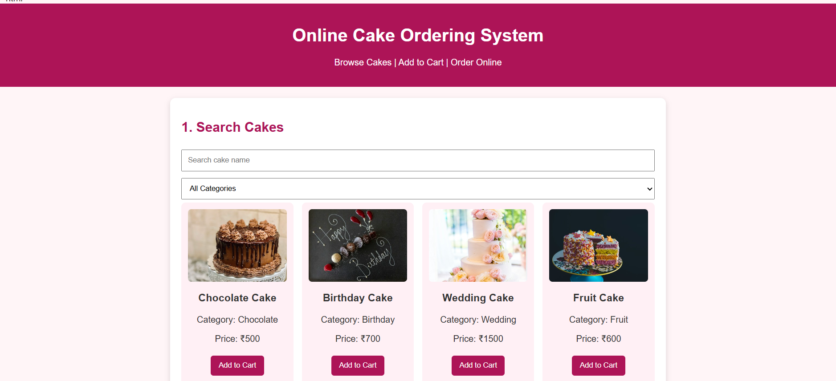
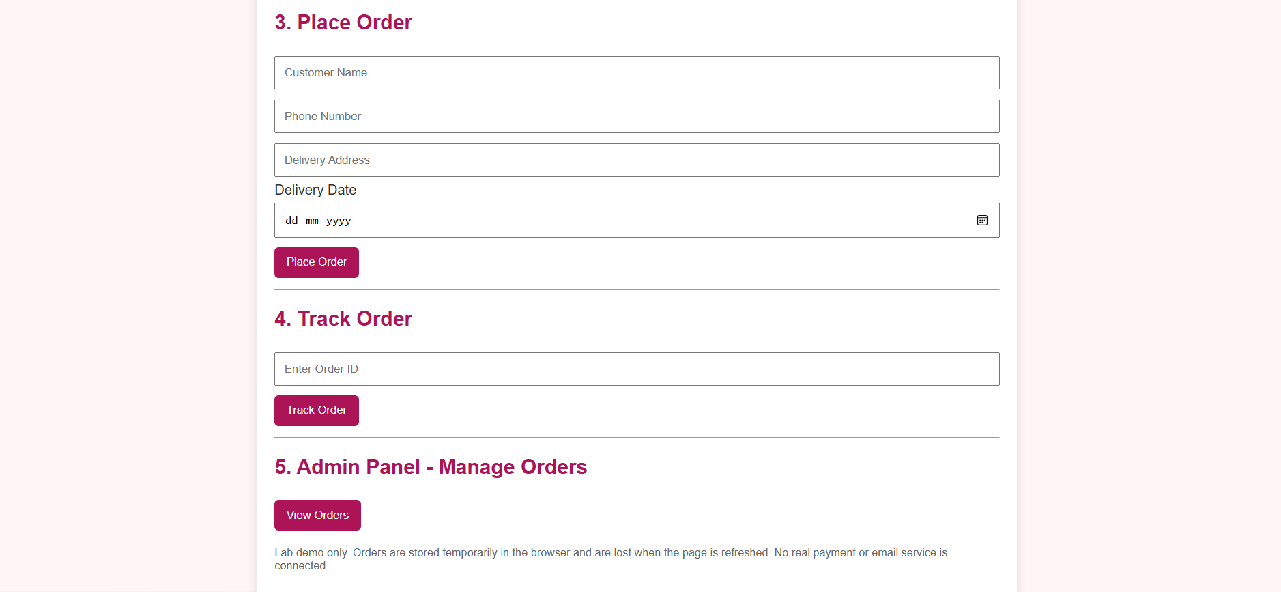

RESULT
Thus, the Online Cake Ordering System was successfully designed and implemented using HTML, CSS, and JavaScript. The system allows users to search cakes, filter by category, add cakes to the shopping cart, place orders, and track order status. The admin panel enables viewing orders and updating their status through a user-friendly interface.

